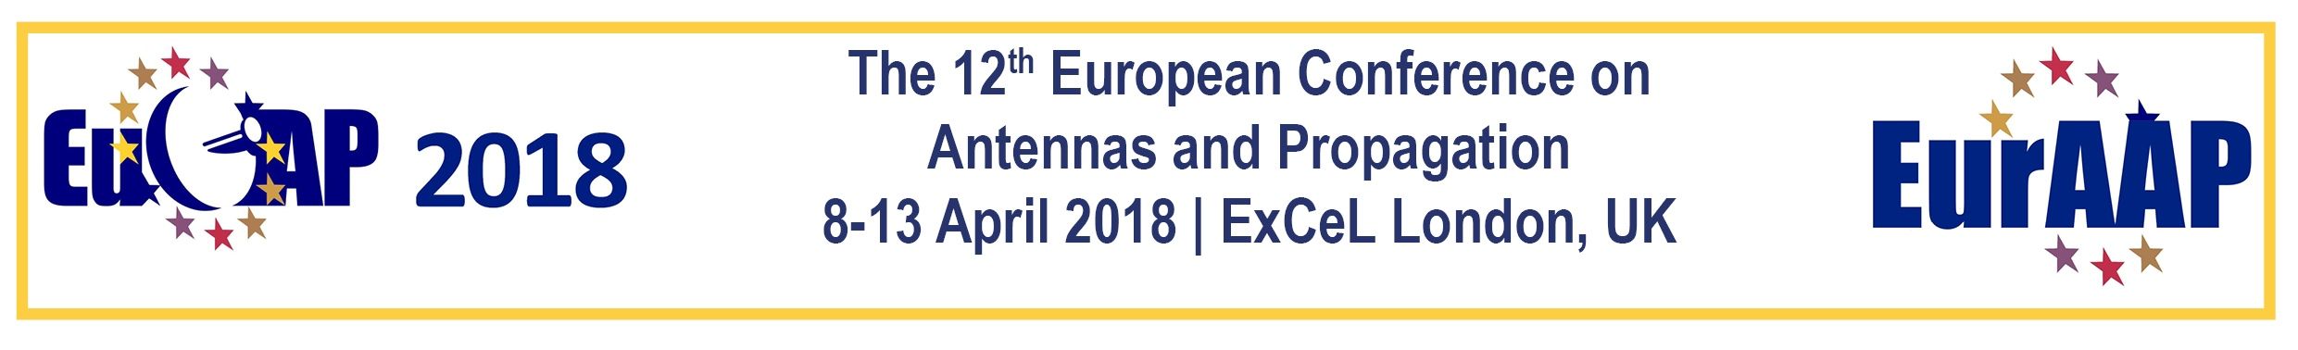
Scientific Workshop Proposal
Submission deadline: Deadline: 15th September 2017
This document is a template for all the information relevant to each scientific workshop to be organised within EuCAP 2018. There can be 1 or 2 proposers. If the proposal is accepted information indicated by an * will be used to advertise the scientific workshop on the conference website.
Please complete and submit by Friday 15 September 2017 in PDF format to EuCAP2018@theiet.org
Please use the following for the email subject line: EuCAP 2018 scientific workshop proposal
Proposer 1 – main point of contact
Name
Company/Organisation
City, Country
Email
Telephone

Proposer 2 (optional)
Name
Company/Organisation
City
Email
Telephone

- Workshop title*

- Why do you think that this is a good topic for a scientific workshop at EuCAP? (100 words)

- Please describe the format for the workshop, identifying the existence of keynote speakers, panel, invited papers, technical sessions, and so on. (100 words)*

- Please provide information on the key people speaking at the workshop (100 words)*
- Conference Topic/Track
Please select the relevant codes(s) from the conference topics and tracks shown on the website, e.g., A14, T10

- Please list the key people for the Workshop Scientific Committee who will solicit the presentations, papers and panels
Name | Affiliation, Country | Email
- Please indicate the number of time slots you will require for the duration of your workshop
1hr 40 min = 1
3hrs 20 mins = 2
5 hrs = 3
6 hrs 40 mins = 4 a full day
- Preferred schedule
Friday afternoon
During the conference (Monday afternoon to Friday morning)
- Any comments:

- Provide any specific plans that may be considered for promoting the workshop

- Has this short course or a similar one already been offered at a conference? Yes/No

- If yes, which conference and year, and with how many attendees

